Help Us Keep Employee Payroll Files Accurate
Employee Payroll Files

At ADP TotalSource®, we work hard to keep the lines of communication with our clients open to make sure you have the most accurate and up-to-date management reports possible. Ensuring data accuracy is a joint effort – and that’s why we need your help.

At the beginning of each calendar year, ADP TotalSource scans all Employee Masterfiles and removes, or “purges,” unnecessary employee records. Normally, an employee record is “Set for Purge” if that employee meets one of the following criteria for the previous calendar year:

Employee has been set to a terminated status

Employee is on active status, but has not received any earnings or compensation since November 18, 2016

There are two options for determining which employees have met the above criteria and are “Set for Purge.”

- AutoPay Master Control report. An employee indicator (“Set for Purge”) appears at the bottom of the Personnel section of the report just beneath the Dates (see example at left).

- Management Report (MR) Download report. The X01 report can be accessed through the Standard Reports section of My TotalSource® to produce the list of employees (see example below). Availability to this report is limited based on your administrator(s) access.

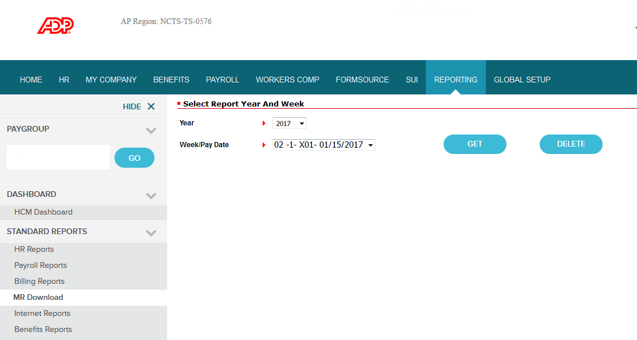

Both of these reports are available once the first payroll of January 2017 is processed. Please review your current AutoPay Master Control report and identify the employees who have the “Set for Purge” indicator – or have your administrator access the MR Download report. If an employee is flagged and you do not want him or her removed from your AutoPay masterfile data, please follow these simple steps:
- Compile a list of employee names in question
- Contact your Payroll Service Representative to discuss if it is appropriate to keep the employee(s) on your payroll masterfile
- Please make your request(s) by February 10, 2017

It is important to note that employees who are allowed to purge will not receive Benefits Enrollment Kits during the upcoming Open Enrollment period beginning in March.
Thank you for your help!

